Visual Studio 2019 C++/CLI Application

Step 1: Open a New Project:
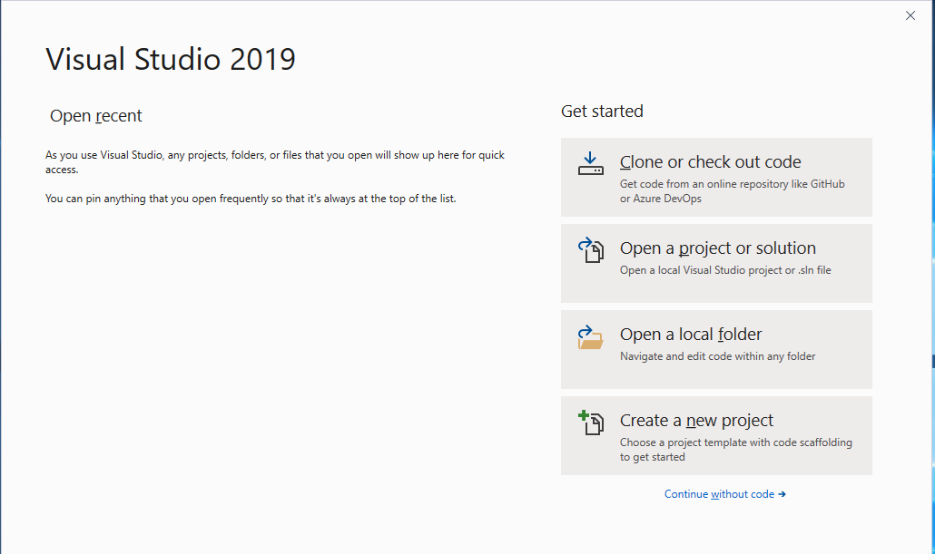
Select Create a new project.

Step 2: Select Empty Project
You will get this screen: 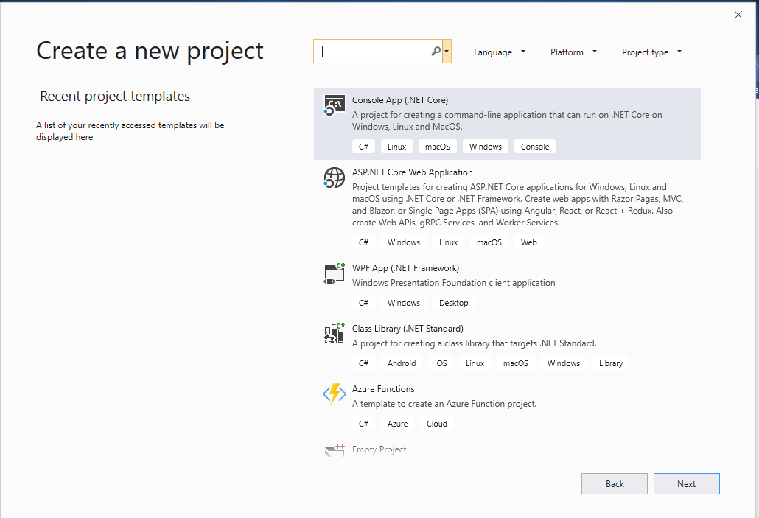
Under All Languages, select C++. Then scroll down until you find CLR Empty Project. There are two. Select the one for .NET Framework, and click next.

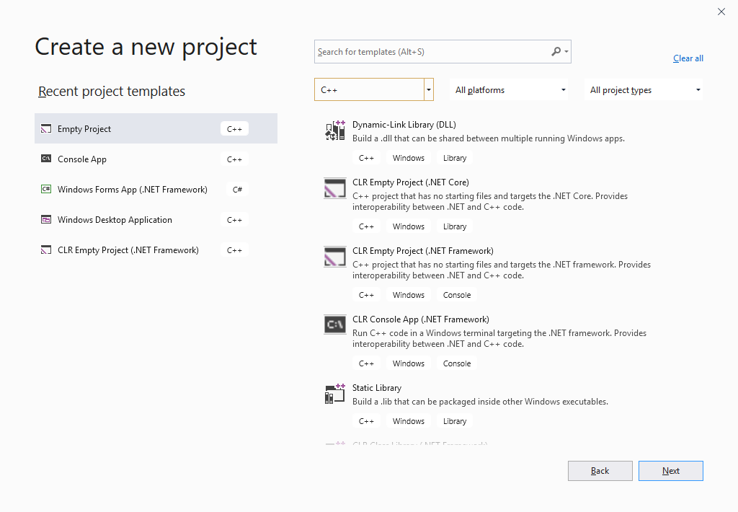

Step 3: Name your project here.

Browse to the location you want to store your project
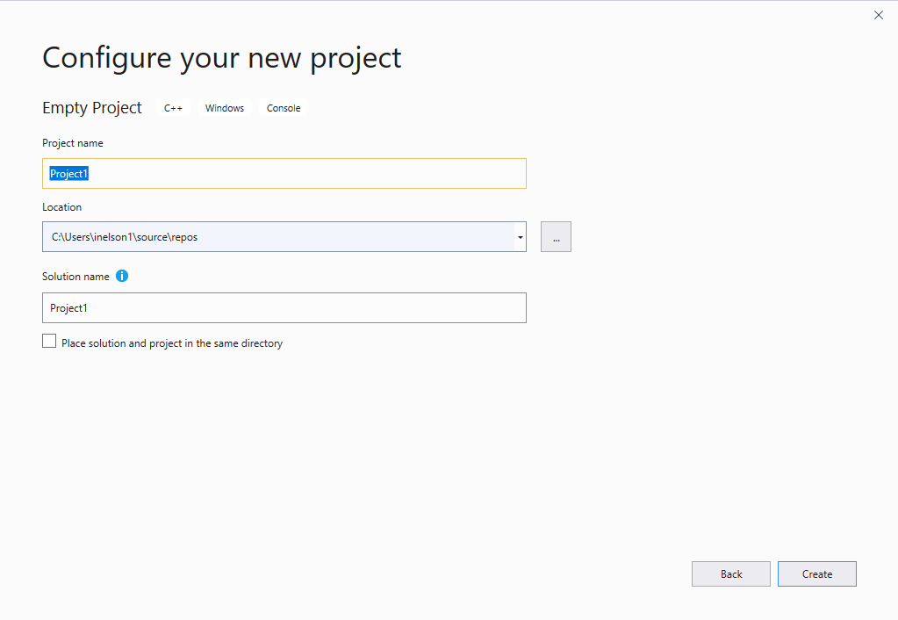

Then click Create.

Step 4: Give it a minute to create the project. This is what you will see – You still need the Form for CLR. Right-click on the Project:
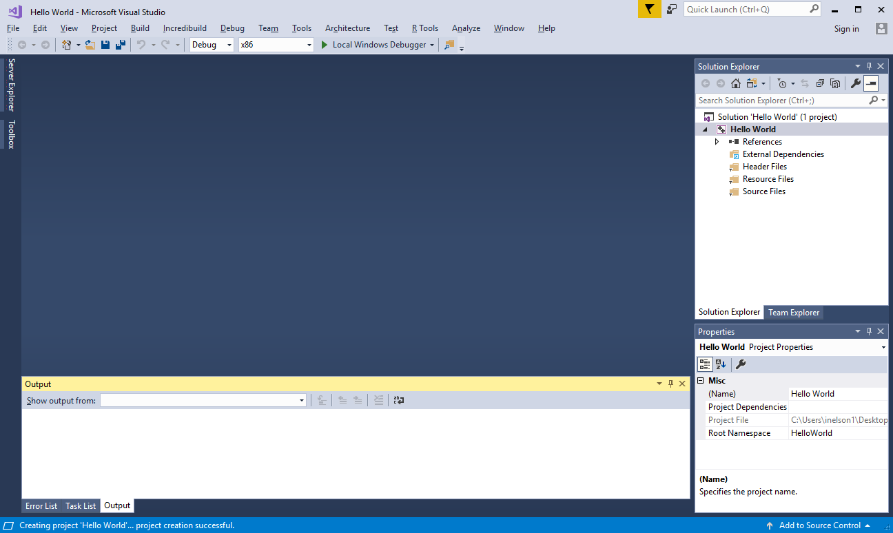

Step 5: Click on Add -> New Item
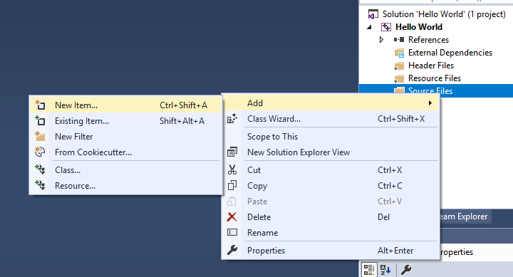

Step 5: You will see this dialog. Select UI at the left. Select Windows Form. Don’t name it, just click Add.
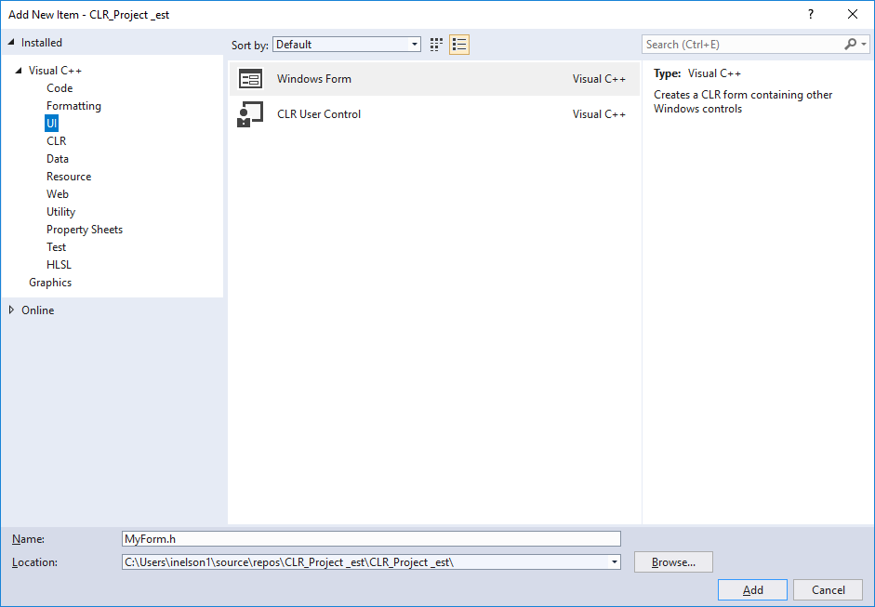
Step 6: You will get an error in the form designer which says: The data necessary to complete this operation is not yet available. (Exception from HRESULT: 0x8000000A), don’t worry. This is a known bug. Notice the file MyForm.h icon looks like a header file. It should be a form.
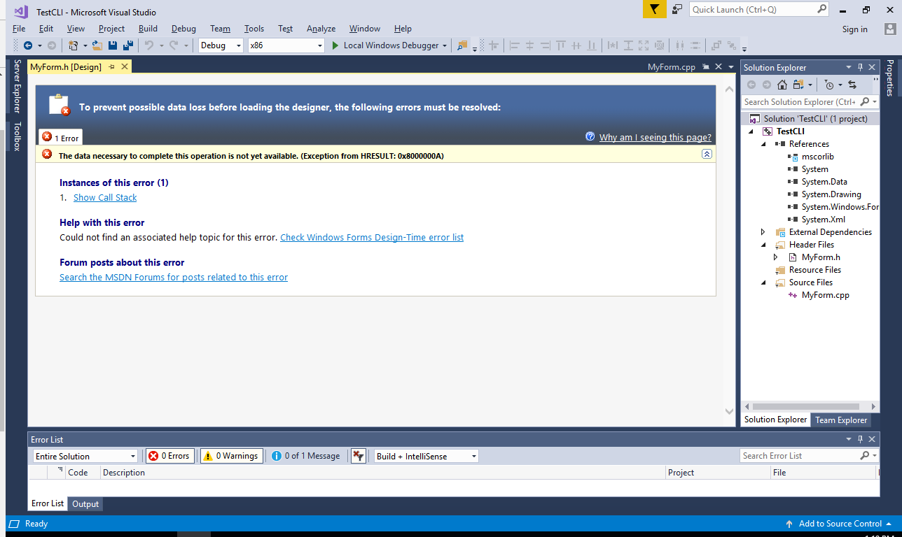
- Close the solution. You will get this window from Visual Studio. Select your Project under Open Recent and re-open it.
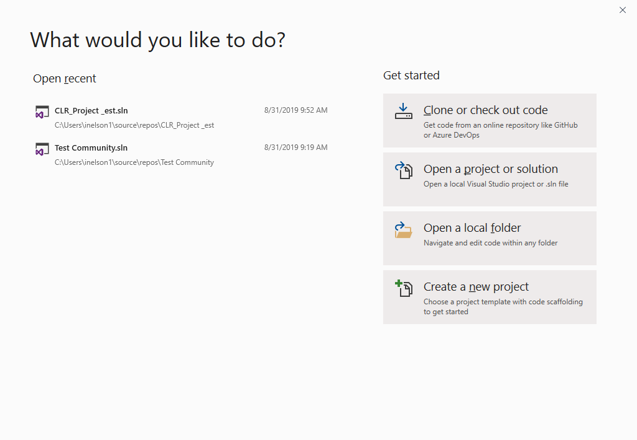

- Now you will get the correct form and your project will look like this:

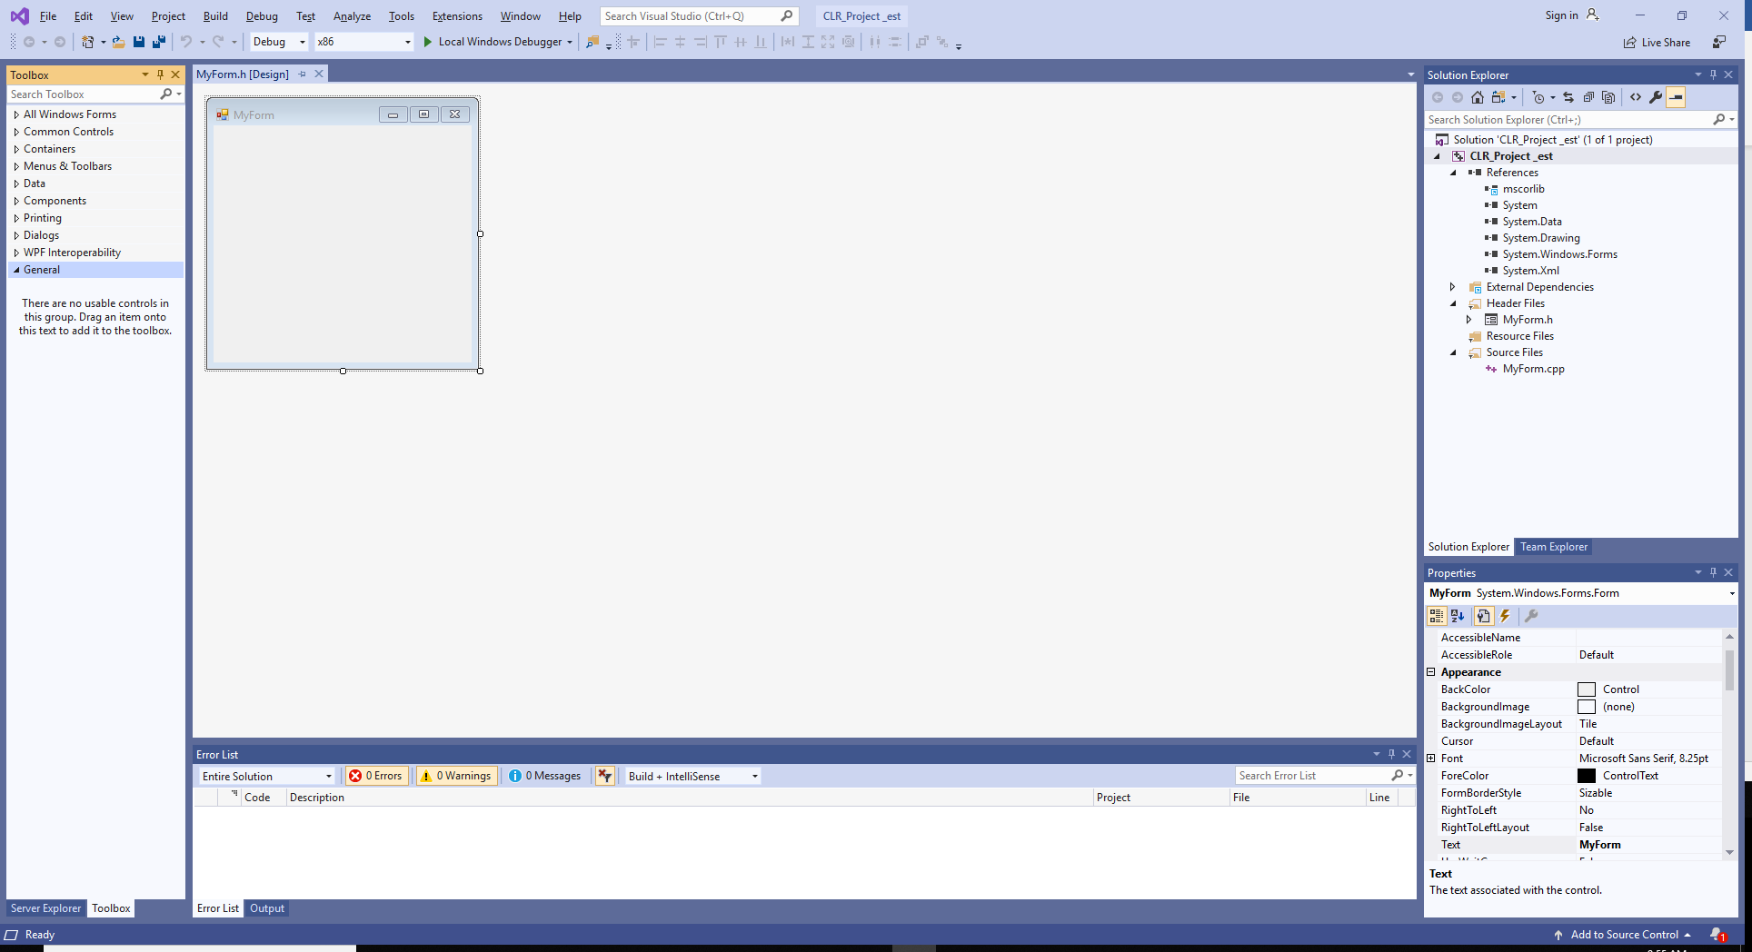

If it still shows the error, check the MyForm.h file in the solution Explorer. If it looks like a form, close the error window and right-click on MyForm.h and select View Designer. That should do it.

- Go to the file MyForm.cpp and make sure the code there looks like this:

#include "MyForm.h"

using namespace System;
using namespace System::Windows::Forms;

[STAThread]
void Main()
{
Application::EnableVisualStyles();
Application::SetCompatibleTextRenderingDefault(false);

[Project name]::MyForm form;
Application::Run(%form);
}

Change [Project name] to your project name or your project namespace if you used underscores in the name. Delete the brackets [ ].

- The System namespace provides functions to work with UI controls.
- Either right-click on the Project name in the Solution Explorer and select Properties or select the Project menu in the toolbar at the top and select [project name] Properties
- Open Configuration PropertiesLinkerSystemSubSystem
- Click SubSystem to get a drop-down menu and select
Windows (/SUBSYSTEM:WINDOWS) Click apply.
- Go to Configuration PropertiesLinkerAdvancedEntry Point
- Click on Entry Point to get a drop-down menu and select <edit>.
- You will see a new dialog box, titled Entry Point. Type in Main, (yes, with a capital M) click OK.

- Click Apply, then OK.
- Run your project. You will see myForm.
- A word of warning. Sometimes (about 50%), when you close and store or zip and upload your project, Visual Studio will lose your settings – steps 13 - 15 above. If that happens, you will have to re-set them when you re-open the project. Remember, never delete your .suo file.

